* *SQL Experiment 1:*

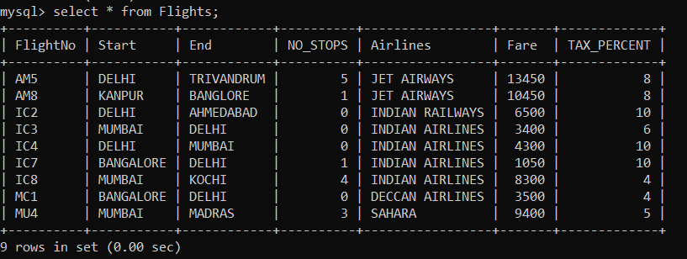

1. To display the Airlines wise average FARE and TAX_PERCENT.

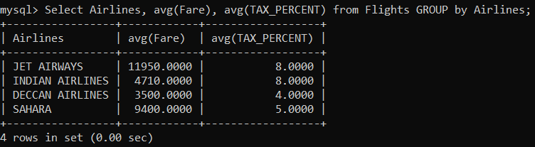

1. To display the FlightNo and Fare is the ascending order of TAX_PERCENT.

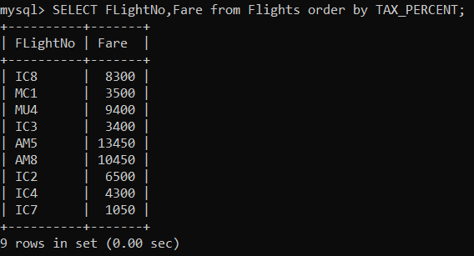

1. To display the Total Price of the Flights from DELHI to MUMBAI, where the Total Price is calculated as: FARE+FARE*TAX_PERCENT/100.

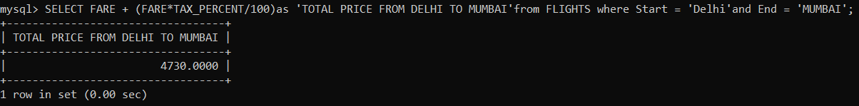

1. To display the minimum fare “INDIAN AIRLINES” is offering.

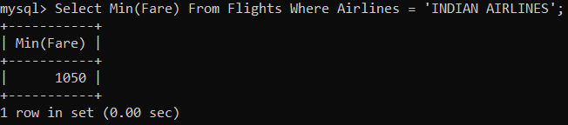

1. To display the AIRLINES in the Ascending order of NO_STOPS and Descending order of AIRLINES.

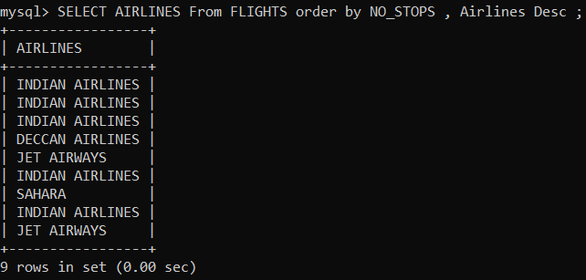

1. To display the total No. of Flights from FLIGHTS where STARTING Starts with letter ‘M’ and No. of Stops is more than 2.

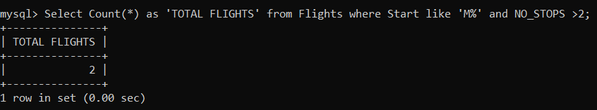

1. SELECT FlightNo, AIRLINES FROM FLIGHTS WHERE START = “DELHI”;

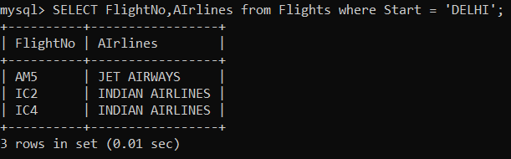

1. SELECT COUNT (DISTINCT ENDING) FROM FLIGHTS;

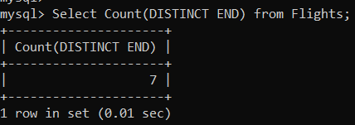

1. SELECT AIRLINES, SUM (FARE) FROM FLIGHTS GROUP BY AIRLINES HAVING SUM (FARE) > 10000;

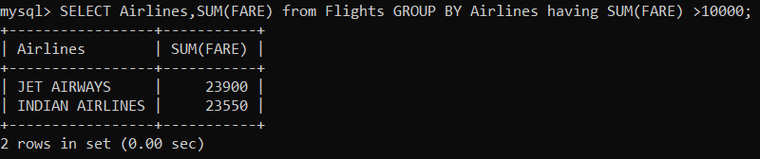

1. SELECT FlightNo, NO_STOPS, AIRLINES, FARE*TAX_PERCENT/100 AS “TAX” FROM FLIGHTS WHERE NO_STOPS BETWEEN 1 AND 3;

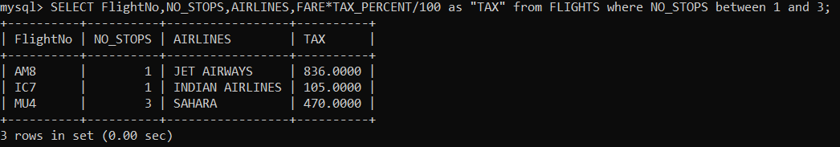

* *SQL Experiment 2:*

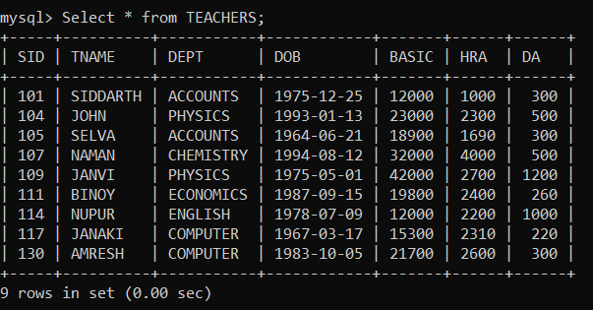

1. To display the names of the staff who are in Accounts department.

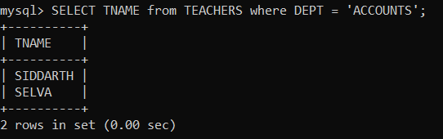

1. To display the Total Pay and Average Pay of all Employees. The salary for one person is calculated as: BASIC + HRA + DA.

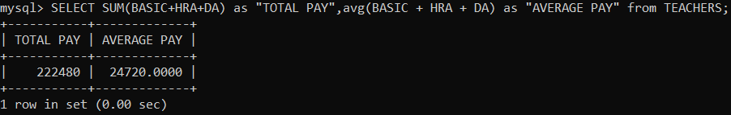

1. To display the names and dept of all staff who doesn’t have ‘a’ in their name.

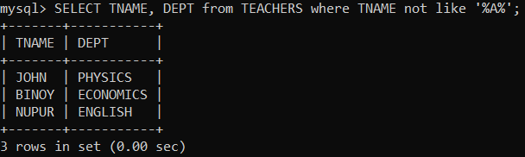

1. To display the SID and Department of the teachers in accordance to the seniority based on DOB.

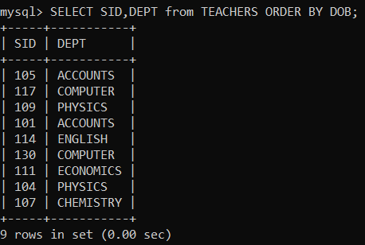

1. To display the report containing SID, SALARY (BASIC + HRA + DA) and PF (BASIC*0.12).

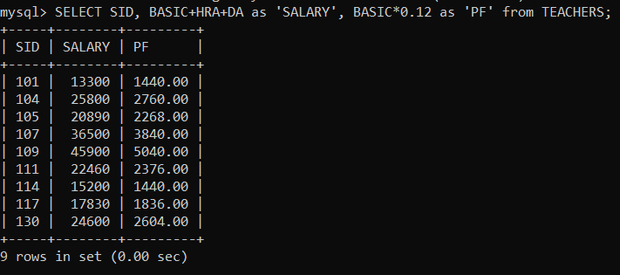

1. To display the details of the teachers who have their DOB in 1975.

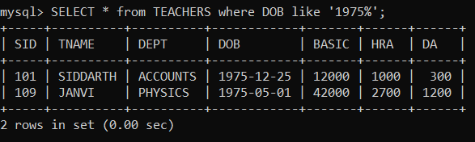

1. To display the no. of teachers in each department.

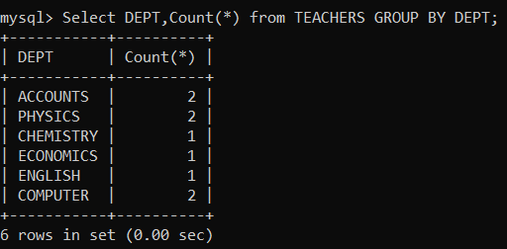

1. SELECT MAX(DOB), MIN(DOB) from TEACHER;

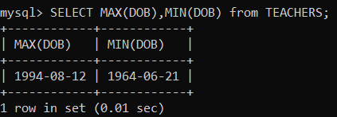

1. SELECT TNAME FROM TEACHER WHERE DEPT IN (‘ENGLISH’,’ECONOMICS’,’ACCOUNTS’) AND YEAR(DOB) BETWEEN 1965 AND 1990;

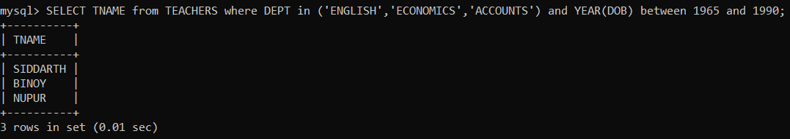

1. SELECT DISTINCT (DEPT) FROM TEACHER;

